High-energy particle bursts detected by GPS satellites in the outer Van Allen Radiation belt as pre-seismic indicators

J. J. Peters

St Mary’s University, Twickenham

(Dated: April 3rd, 2018)

Experimental data on high-energy charged particles, obtained from GPS satellites in MEO opposed to LEO, have been processed and analysed with the goal of finding particle bursts of a seismic origin. Expanding upon work done by Wach (2017) into nuclear weapon tests [1], using data provided by the CXD team [2], itself based upon work done by Alesandrin, et al. with LEO satellites SALYUT-7, METEOR-3, GAMMA-1, and SAMPEX [3]. Coincident bursts and seismic events have been observed with a 5-sigma confidence level [3]. This is a stark comparison to the 3-sigma confidence obtained though there are indications of either an incorrect capture altitude being used, being between 550-700km opposed to 300-500km [3], or an issue with incompatible methodology. The latter of which seems to be the case based upon observations made regarding the outer Van Allen belt. It was found that the GPS satellites could also offer information into the outer Van Allen belt as it varies between 2001 and 2017. While the electron count rate did not seem to respond to sunspot activity, it was possible to confirm the stated 65° either side of the celestial equator [4] figure to (55±15)°.

# Introduction

Surrounding many planets in our solar system there is a vast and dynamic region of space called a magnetosphere which is strongly influenced by the magnetic field of the planet it surrounds [5] [6] [4]. Earth has its own magnetosphere and, in our solar system, has the strongest of all the rocky planets [5]. This region plays a crucial role in Earth’s habitability as it shields the Earth from both solar and cosmic radiation as well as our atmosphere from erosion [5]. The lower part of the magnetosphere begins at around 80km and extends out 65,000km or 10 Earth radii ( $R_{E}$ [see appx 1]) along the side facing the sun [5] [6]. The magnetic field takes upon a structure of an ideal dipole within the distance of several $R_{E}$ from the Earth’s centre [6] [4].

Well inside the magnetosphere are the Van Allen radiation belts where ions and electrons experience long-term confinement in the geomagnetic field tube; this is due to the dipolar construction of the magnetic field which field lines converge at high latitudes [4] [7] [8]; a description of the motion of these particles can be seen in figure 1. The inner Van Allen belt generally extends between 640-9650km (0.2 to 2 $R_{E}$) and the other belt between 13,500-58,000km (3 to 10 $R_{E}$) [7]; and the magnetic geometry imposes angular limitations to these radiation belts to about 65° either side of the celestial equator [4]. The Van Allen belts are stated to respond to incoming radiation/energy from the sun and this can be tied to the sunspot activity seen in figure 2 [7].

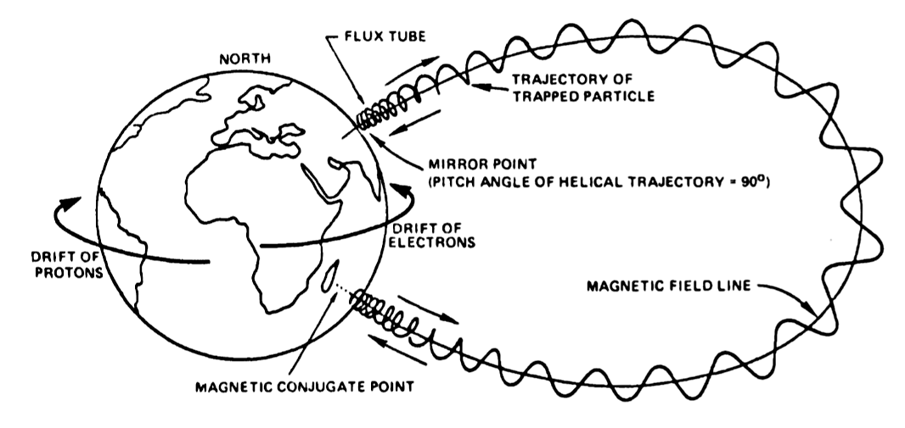

Figure 1 - A drawing of the three main types of motion that trapped, charged particles experience in the Earth's magnetic field [8].

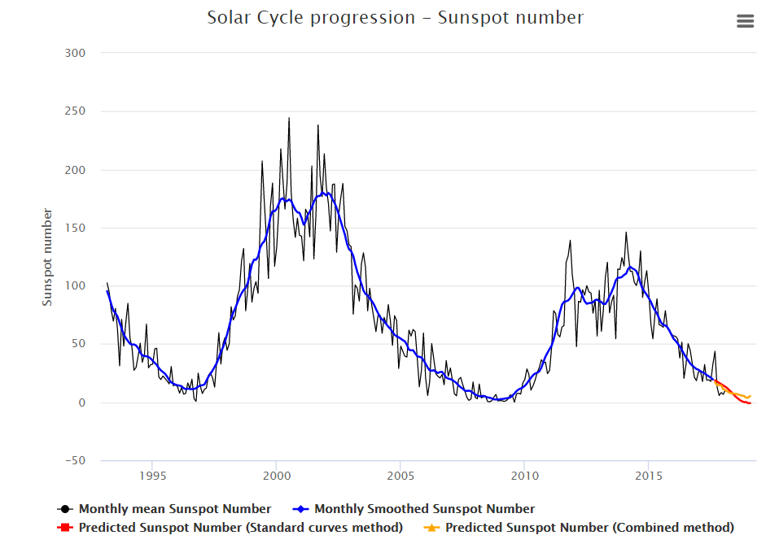

Figure 2 - Graph showing solar cycle progression in terms of sunspot numbers (monthly mean) between the early 1990s and 2018 with prediction into the future. [9]

The inner belt is comprised of protons exceeding 100 MeV and electrons of a few 100 keV. Compared to the inner belt, the outer belt lacks the many protons and instead has higher energy electrons of the order of 0.1 to 10 MeV and is mostly concentrated between 4 to 5 $R_{E}$ [10]. This behaviour can be seen in figure 3a and 3b in terms of particle fluxes. The region between the two Van Allen belts, between 2 to 3 $R_{E}$, is stated to fairly be empty [7].

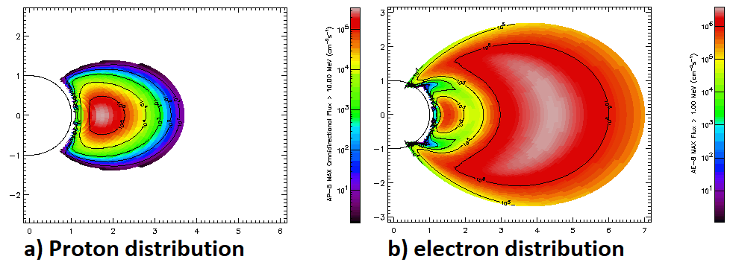

Figure 3 - Electron and Proton flux distributions above the Earth's celestial equator. [10]

Within the Van Allen radiation belts, short-term variations or particle bursts (PBs) in the near-Earth space have been shown to have a correlation with pre-seismic electromagnetic emissions (EME) [11]. While PBs are not the only measurable result of a pre-seismic EME, alternatives such as magnetosphere substorm generation (or AE-splashes), these are the primary focus of this research [12]. These EMEs are generally of ultra low frequency (ULF), f < 5Hz, or extra low frequency (ELF), f = 30 - 300 Hz, and are produced through both direct and indirect pre-seismic processes [11].

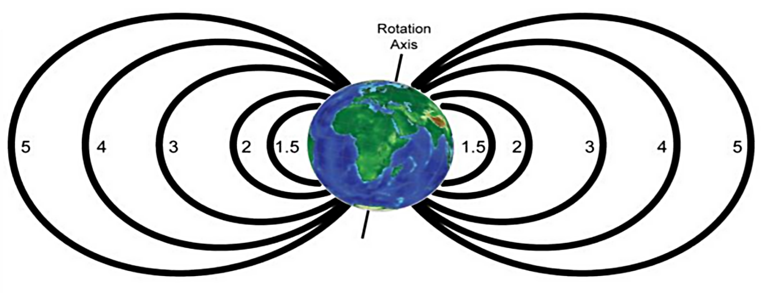

Figure 4 - This is a plot of the Mcllwain L-parameter (also known as the L-shell/L-value). It describes a set of planetary geomagnetic field lines. The L-value itself describes the set of field lines which cross the planet’s magnetic equator at a multiple that planet’s radius. Ie, in the case of this plot for the Earth, an L value of 4 describes the field lines which cross the Earth’s magnetic equator at 4 $R_{E}$ from the centre of the Earth [11].

The released pre-seismic EME is captured near the ionosphere-magnetosphere transition region, around 300-500km, and then proceeds to travel along the geomagnetic field tube (related to the specific L-shell that the event originated from) [3] [11]. Once the EME reaches the inner Van Allen radiation belt boundary, a cyclotron resonance interaction occurs, and this causes particle precipitation [3] [11]. This process causes the mirror points to be lowered which allows particles to precipitate down towards satellites [11]. This occurs as the oscillation frequency of the confined particles between the two mirror points is approximately the same as the frequency as the EME [11]. The process creates a wave of precipitated particles that would make one or more revolutions of Earth before being damped [3].

Further analysis was carried out on the spatial distributions of the particle burst and the seismic event and it was found that the two would be located on nearly the same L-shells [3]; Though, due to charged particle drift, the PB can be observed at any longitude as long as the satellite crosses the disturbed L-shell [3].

So far, past research has been done primarily with satellites that reside in a low Earth orbit (LEO), ie between 160 to 2,000km. Such as with SALYUT-7 ([341:344]km, 51.59), METEOR-3 ([1208:1236]km, 82.55), GAMMA-1 ([319:726]km, 51.29), and SAMPEX ([514:689]km, 81.67) [3] [13]. NB – in the form of ([perigee:apogee]km, inclination (degrees)).

# Literature review

Earthquakes are among one of the most destructive forces in nature and give rise to destructive secondary events likes Tsunamis, landslides, etc. While infrastructure damage and death mitigation can be achieved through various engineering techniques, there are factors that can be seen to be outside of being predictable. An early warning system, while it likely wouldn’t help infrastructure damage, would likely assist in reducing loss of life and loss of fragile products.

Current early warning systems rely on an Earthquake having already occurred [14]. The P waves produced by an Earthquake travel faster than the more destructive S waves, this allows seismometers to pinpoint the epicentre of the Earthquake and then estimate the time it would take for the S waves to reach major cities [14]. Worse case the system can provide a 10 second warning for those situated near the epicentre and up to 5 minutes further out [14]. The forecast capabilities of this system are limited. While it can help significantly reduce the loss, it might not be enough in certain cases and addition warning could further reduce loss. Thus, an early warning system that can detect an impending seismic event prior to the event occurring would be beneficial.

A correlation between particle bursts in the near-Earth space and seismic activity was first pointed out in 1987 by Voronov, et al. [3] [15]. More detailed studies where carried out two years later in 1989 by Galper et al. and Voronov, et al. in 1990 [3] [15]. In Galper, et al. (1995), histograms where produced comparing the temporal difference between seismic event, within ±6 hours, of magnitude greater than 4 with sharp increases in particle count rates [15]. From this, it was found that that there was an increase of events in the 2-3 hour region prior to the main shock [15]. As was concluded in the article, it was a method that could possibility be developed into a short-term earthquake prediction system.

Work into this methodology was continued and in 2002 some of the main researchers termed up to provide a more definitive view. In the article ‘High-energy charged particle bursts in the near-Earth space as earthquake precursors’, S. Yu. Aleksandrin, et al.; work done prior was collected and improved upon [3]. A few key changes had been made: that the L-shell would be less than 2 for LEO satellites, the South Atlantic Anomaly region would be excluded, and the time interval was doubled to ±12 hours [3]. From this refinement to the methodology since Galper, et al. (1995) the previous 2-3 hour region was increased to 2-5 hours prior to the main shock [3].

Further work done in the article explored how varying the L-shell cut or the EME capture altitude alters the confidence level of the peak of the temporal distribution histograms. These where important discovers as it gave the most optimal capture altitude range of between 300-500km for L values below 2 and showed the most optimal spatial L-shell for the dataset of 0.07 [3]. Not only did this article confirm and reiterate work done previously, but it improved upon the methods that had been used prior. It also further iterates the claims made in Galper, et al. (1995)’s work that it could be used in prediction of seismic events [3]. The work done in Aleksandrin, et al. shows that the methodology has developed but there are a few outstanding issues. The first is that the satellites that have been analysed stopped producing data prior to the release of the article, given this fact the methodology constructed may not apply to newer satellites and those in differing orbits. Secondary, there is also the concern that while these PBs can be shown to have a temporal and spatial correlation to seismic events, the actual Earthquake prediction methodology has not been shown. Finally, given the restriction on the L-shells, the technique is spatial restrictive.

The spatial restrictions of the previously mentioned methodology was partially resolved by work done by F. M. Wach in 2017. While the work was primarily focused on exploring signatures left by nuclear weapons in the Van Allen Belts it was based upon the same methodology outlined in Aleksandrin, et al. (2002) [1]. In this paper, Wach explored the use of using GPS satellites equipped with Burst Detector Dosimeters which provided an L-shell coverage between 4 and 5 [1]. The paper only partially explores the application of past work to this new dataset and makes an incorrectly statement about how the produced histograms match past literature. The temporal correlation histograms given in Wach’s paper show notable peaks at approximately -11, -2 to -4, +2 to +5, and +8 to +10 hours [1]. In past literally, like Aleksandrin, et al., peaks can only be seen between +2 to +5 hours [3]. Furthermore, this correlation is only tested for a single satellite, SVN56 [1]. Given the number of GPS satellites that are actively collecting data, and their L-shell coverage, a deeper look into the whether a temporal and spatial correlation can be seen would be prudent.

In the following research paper, I expand upon an area of F. M. Wach’s research into applying Aleksandrin, et al. PB seismic event correlation to GPS satellites. I have the following points which I wish to explore.

1. What information on the outer Van Allen radiation belt is obtainable using the GPS satellites.
2. Is there a temporal and spatial correlation between PBs detected by GPS satellites and seismic events.
3. If there is a correlation between PBs and seismic events, what is the capture altitude and optimal L-shell cut.

# Methods

## Instrumentation

The data that is used for this project comes from The CXD team at Los Alamos National Laboratory. It was collected between January 7th, 2001 and January 1st, 2017 using a total of 23 GPS satellites launched prior to and during this time frame. The following satellites have an orbital altitude of around 20,200km or 3 $R_{E}$, which places them in a medium Earth orbit (MEO), and this gives them an orbital period of about 12 hours. The satellites are equipped with either Burst Detector Dosimeters (BDD) instruments (for SVN41&48), or Combined X-ray sensor and Dosimeters (CXD) based instruments (for SVN53-73) which take measurements of both electron and proton count rates across multiple energy channels, in Hz, every 240 seconds. Satellites equipped with a BDD instrument can measure across 8 energy channels; while CXD based ones have 11 electron energy channels and just 5 proton energy channels. In addition to the particle count rates, the satellites also record their geographic latitude and longitude, L-shell, magnetic longitude, etc [2].

A full breakdown of the orbital altitude and inclination for each satellite the dataset can be seen in APPX2 [13] [2].

## Correlation between PBs and seismic events

To investigate any potential correlations between PBs detected onboard a GPS satellite and surrogate seismic events, I was lucky enough that my University, St Mary’s University, Twickenham, and the University of Bristol are in partnership. This meant that I was able to build upon the work done by Wach, F. M. in his project which in itself seems to be based upon work done by Aleksandrin, et al. with LEO satellites (2003) [1] [3].

From the CXD teams satellite data and work done by Wach, it was found that channel 2 (ch2) electron rate saw the most significant increase surround a seismic event; as such it was chosen channel for all analysis in Wach’s project report. From my own findings when exploring the data, I came to the same conclusion with ch2’s response to seismic activity.

We define a PB as where the ch2 rate exceeded the ch2 average by at least four sigma. Analysis of the temporal and spatial correlation between the PBs and seismic events was carried out using the same procedure for all analysis with one exception; Originally the $∆$ T cut-off was set to 12 hours however, given the difference in the dataset, I had decided to expand this range. If it was found that there was no notable correlation pas a $∆T$ of 12h, we could simply ignore additional matches. Seismic events with magnitudes M > 4 from the USGS Earthquake Catalog were selected [16]. These seismic events where then temporally and spatially correlated to our PBs.

$$∆T= T_{EQ}-T_{PB} \left|∆T\right|<12h \left(or 48h\right) \left(1\right)$$

$$∆L= L_{EQ}-L_{PB} \left|∆L\right|<cut-off (2)$$

The ∆L value in equations 1 and 2 is an additional parameter where, depending on what we are trying to measure, the ∆L cut-off can be varied. As the name might imply, it is the allowance on the L-shell value in the spatial correlation. We can obtain the L shells of our seismic events by converting the epicentre location of the seismic event into an L-shell assuming an EME capture altitude of 400km. The L shell of the satellite is provided in the GPS data files. We would vary our ∆L cut-off, between 0 and 0.2, to alter the spatial cut applied to our dataset. From this, we could plot confidence of our peak (equation 3) against varying ∆L to see how ∆L affects our data quality. We can also see that the EME capture altitude can also be considered a free parameter, as it can be varied between 0 and 2000km, to also see how our confidence changes with altitude.

$$n_{σ}=\frac{(N_{max}-\overline{N})}{σ} (3)$$

$n_{σ}$ is the confidence level of the peak, $N_{max}$ is the number of events in the peak of the ∆T histogram, $\overline{N}$ is the average number of events in the ∆T histogram, and $σ$ is the standard deviation.

## Van Allen radiation belt size and response to solar weather

While the satellites in the dataset only have a 55° inclination, based upon initial exploration of the raw data shows that the angle of some of these satellites can be as travel as much as 75° above the geomagnetic equator. Based upon the previously stated 65° limit for the Van Allen belts it does seem like measurement of the angular extent over time is possible. Given the dataset is divided into one week blocks for each satellite this provides us with a time division to apply the analysis to.

A data file itself does not contain the current inclination angle that the satellite is at rather it has measures of its altitude and its height above the Earth’s magnetic equator. Through applying trigonometry, I am to obtain the satellites current inclination. It is then possible to plot the particle count rate against the satellites current inclination. From such a plot a determination of a method to obtain the angular extent of the belts should then be possible. I suspect that I will try to fit a model to the data or, if that fails, a cruder measure. With either approach I suspect that uncertainty in the result will be high.

The exploration of the particle count rates in response to solar weather can be done by taking the minimum, maximum, and average of the particle count rates from a single data file. These could then be plotted over the full time range for a single satellite. It would then be possible to compare multiple of these plots to a solar activity to see how all the satellites, and in turn the Van Allen belts, respond. I have chosen to use the sunspot activity as a solar activity measure and it can be seen in figure 2. Given the orbital altitude of our satellites, placing them in the outer Van Allen belt, I do not believe that proton count rate will not be much use.

# Results

## Correlation between PBs and seismic events

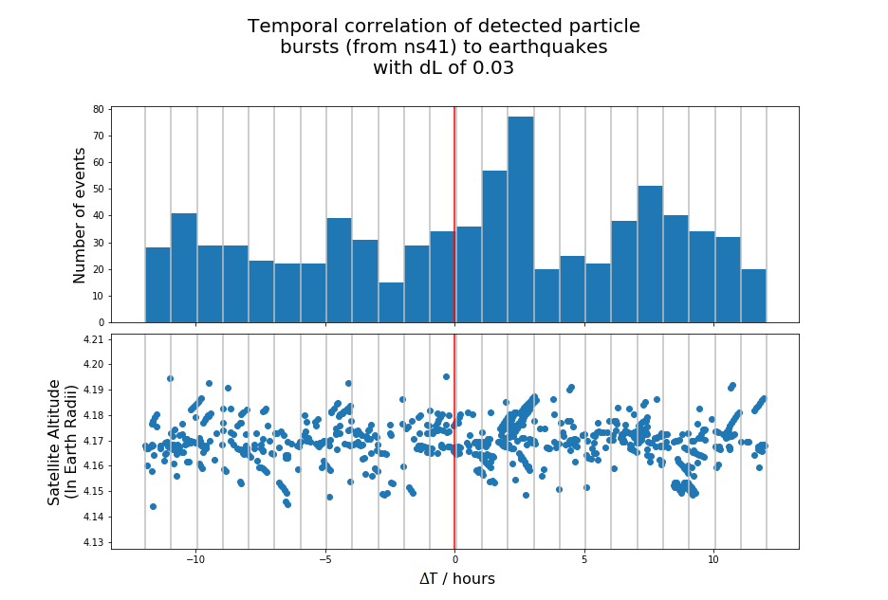

Figure 5 - ∆T distribution histogram for SVN41 with a satellite altitude plot. Red line at ∆T = 0 marks the seismic event. Our ∆L cut is 0.03.

Figure 5 shows a well-defined peak between +1 to +3 hours for SVN 41 with a ∆L of 0.03; Satellite Altitude spread between 4.14 to 4.20 $R_{E}$. Addition plots with varying ∆L in [Appx 3].

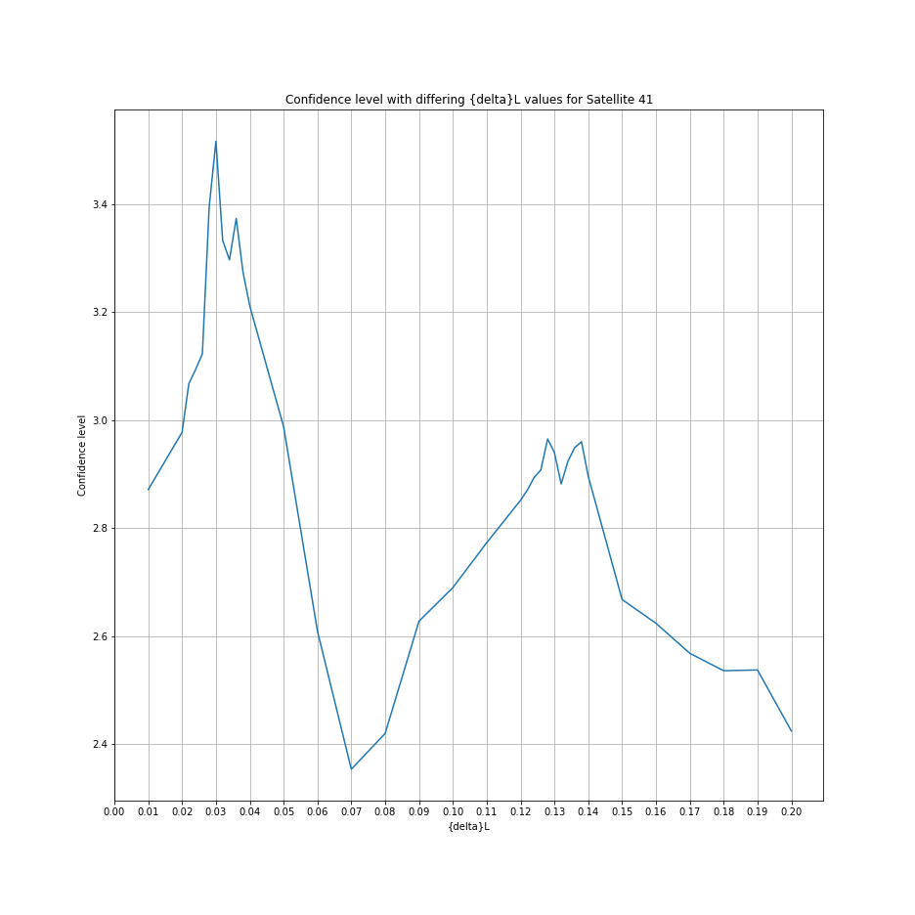

Figure 6 - Plot of confidence level (eq. 3) against ∆L cut for SVN41.

From figure 6 there are two confidence peaks at ∆L=0.03 (3.5±1.3) $σ$ and ∆L≈0.13 (2.9±0.3) $σ$. It should be noted that our overall confidence is less than 3.5 $σ$. ∆L=0.07 shows a minimum at (2.3±0.2) $σ$.

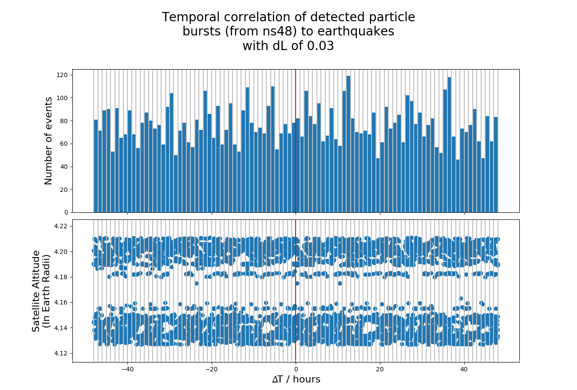

Figure 7 - ∆T distribution histogram for SVN48 with a satellite altitude plot. Red line at ∆T = 0 marks the seismic event. Our ∆L cut-off is 0.03. This is with an extended ∆T cut to 48h.

Figure 7 shows the ∆T distribution histogram for SVN 48. As can be seen there is no well-defined peak though many peaks exist. There is a satellite altitude splitting behaviour that is occurring where two clear bands are forming; 4.13 to 4.16 and 4.18 to 4.21 $R_{E}$, the region between these two bands is mostly void of data. Addition plots of varying ∆L can be seen in [Appx 5].

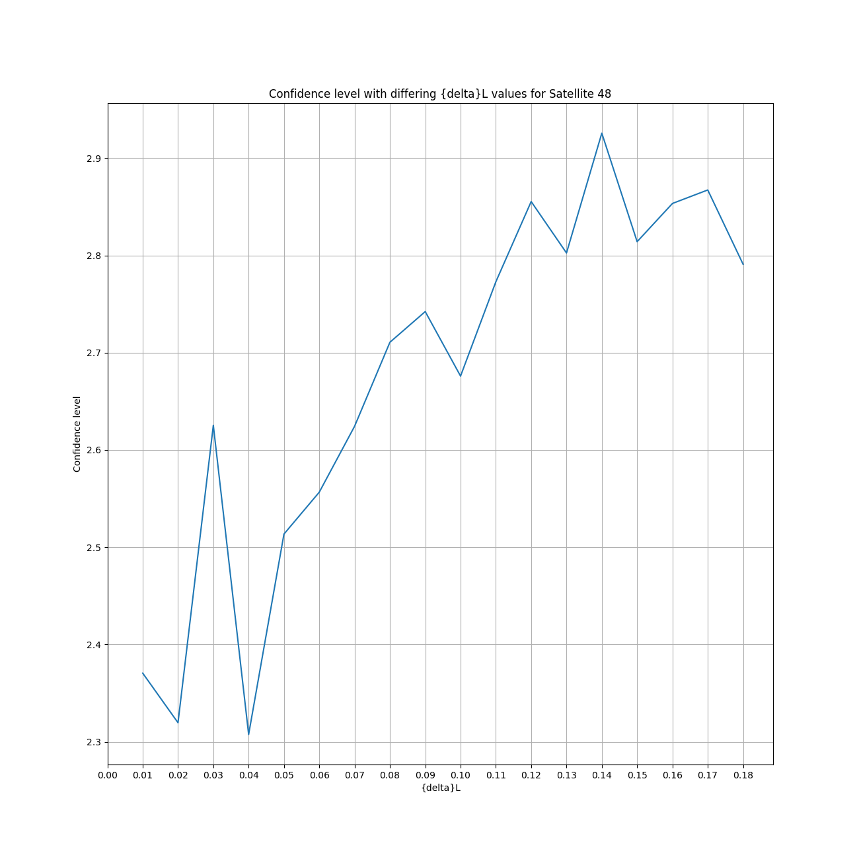

Figure 8 - Plot of confidence level (eq. 3) against ∆L cut for SVN48.

Figure 8 shows two peaks in the confidence plot for SVN48 as we vary ∆L. These peaks can be found at ∆L=0.03 (2.6±0.4)σ and ∆L=0.14 (2.9±0.2)σ respectively. The peak at ∆L=0.03 seems to be flanked by a sharp drop either side. The overall confidence is mainly less than 3σ.

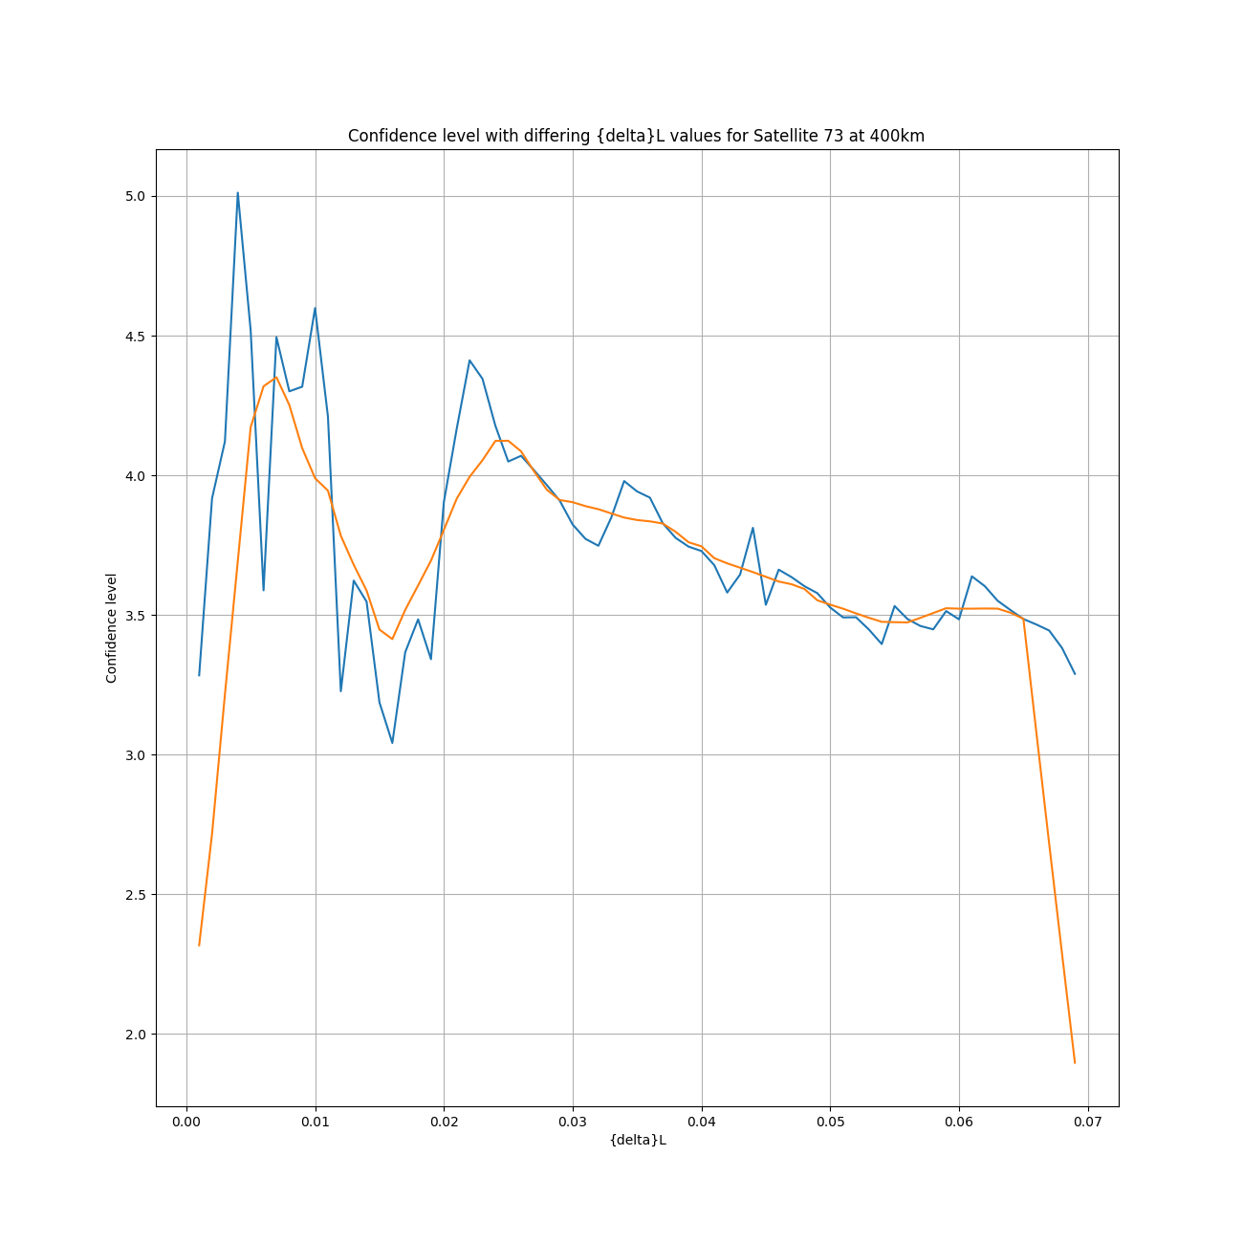

Figure 9 - Plot of confidence level (eq. 3) against ∆L cut for SVN73. Orange line is a smoothed series to help show how the confidence varies.

Figure 9 shows confidence with varying ∆L cut between 0.00 and 0.07 for SVN73 (similar results with SVN70-72). The number of samples in the ∆L cut is higher and thus the inclusion of a smoothed series to help show trends has been included in orange. The smoothed series shows anomalies close to 0.00 and 0.07 due to the method used. The average confidence is around 3.7 $σ$. There are two ‘peak clusters’, one which exists in the 0.00 to 0.01 range which fall between 4 $σ$ and reach up to 6 $σ$, and a second group which are between 0.02 and 0.03 which have confidence in the range 4 $σ$ to 5 $σ$.

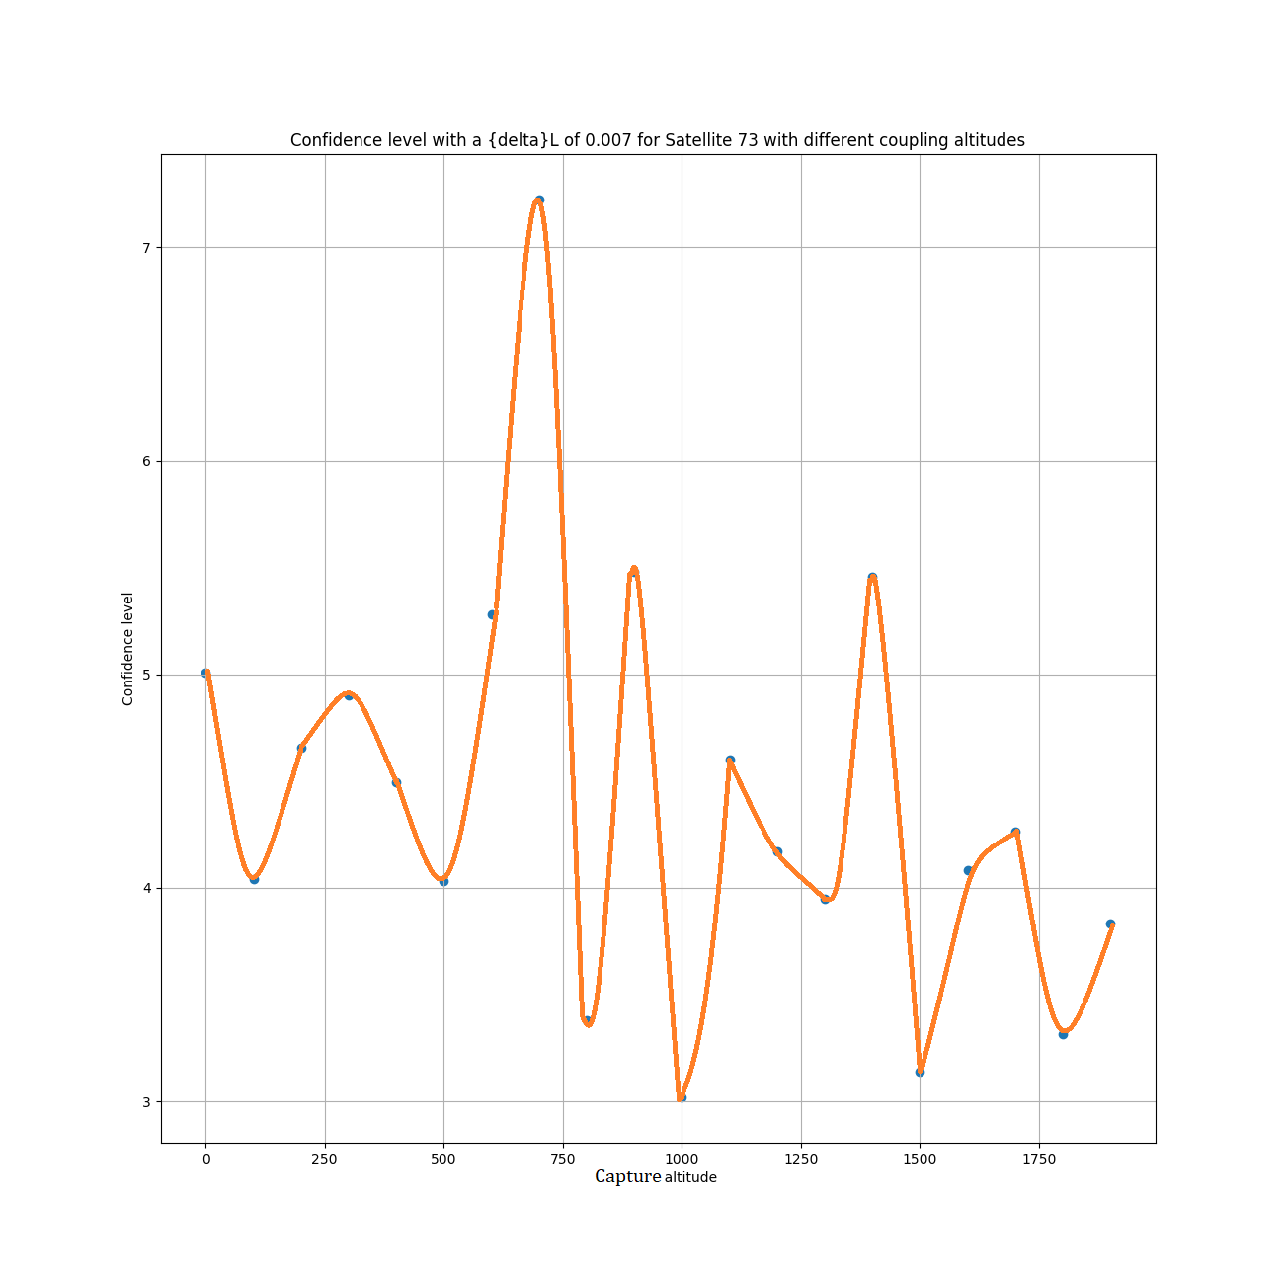

Figure 10 - Confidence level of SVN73 with a ∆L cut of 0.007 with varying EME capture altitude.

Figure 10 shows the result of varying the EME capture altitude to confidence if the ∆L cut is 0.007. The standard capture altitude used for most of the previous results was 400km which provided confidence results in the range of 4 $σ$ to 5 $σ$. From figure 10 a capture altitude between 550km and 700km results in an apparent confidence exceeding 5 $σ$ with peak confidence obtained at approximately 650km with confidence exceeding 7 $σ$.

## Van Allen radiation belt size and response to solar weather

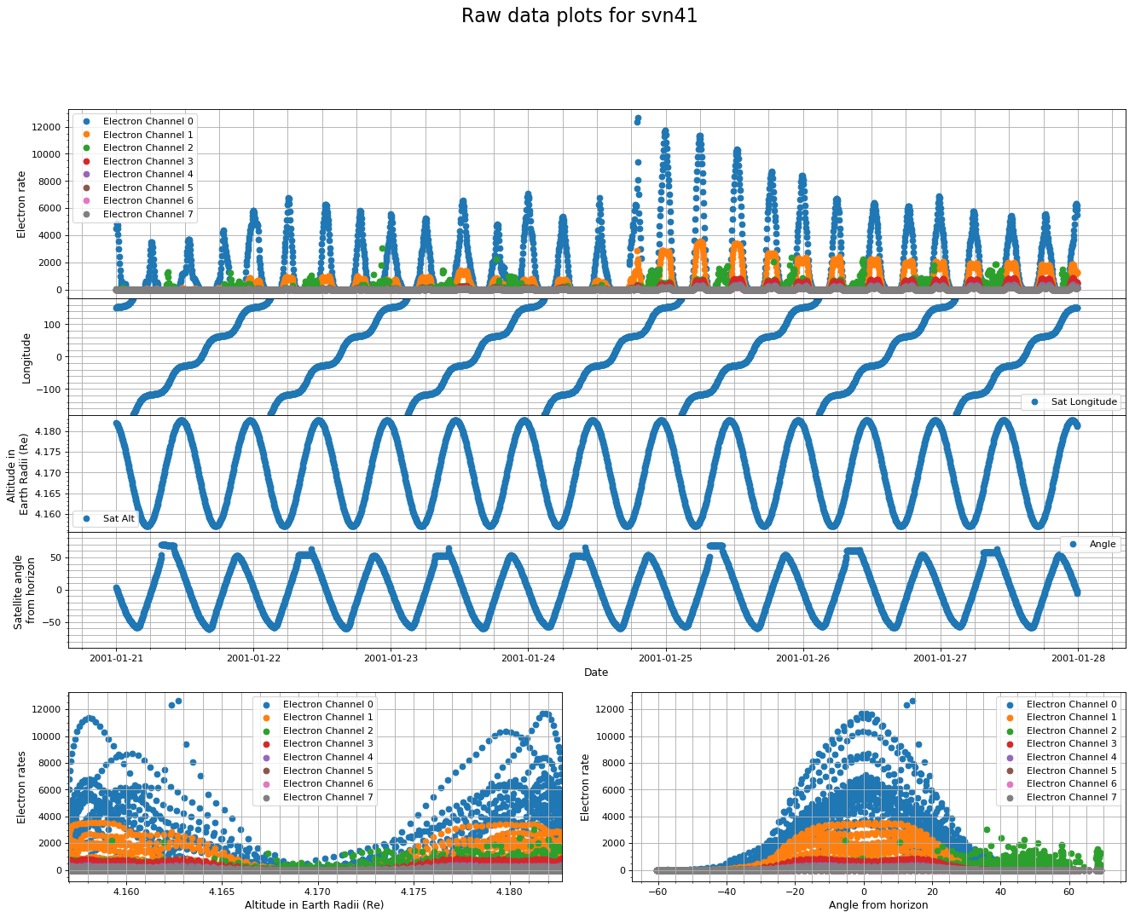

Figure 11 - Plot of the raw data from SVN 41 between 2001-01-21 and 2001-01-27. Shows how all 8 electron rate channels act over this time frame in addition to the distributions in terms of Earth Radii and angle from horizon that data is collected over. Plots of the Satellites longitude, altitude in Earth Radii, and angle from horizon are also included.

Figure 11 shows a plot of a single data file, ie 1 week of data, from SVN 41. The electron rate channel 0 (ch0 etc.) shows a repetitive behaviour where it’s count rate will be near 0Hz and then spike up to 2000Hz or more. This behaviour seems to last for a few hours before a period of non-activity, or sub 100Hz. Other channels, ch1 & ch3 mainly, appear to also show similar characteristics. These similarities continue into the electron rate vs. altitude and electron rate vs. angle from horizon plots. Channel 2 (ch2), the channel selected for its seismic response properties, appears to respond differently. Most notable in the electron rate vs. angle plot where ch0 shows response between -40° to +40°, and ch2 appears to spread from 0° to +70°. The distributions seen in electron rate vs. altitude differs during alternate time frames and for electron rate vs. angle the distribution shows a similar shape and spread, but ch2 may span from -65° to 0° degrees. Additional plots can be seen in [Appx 5].

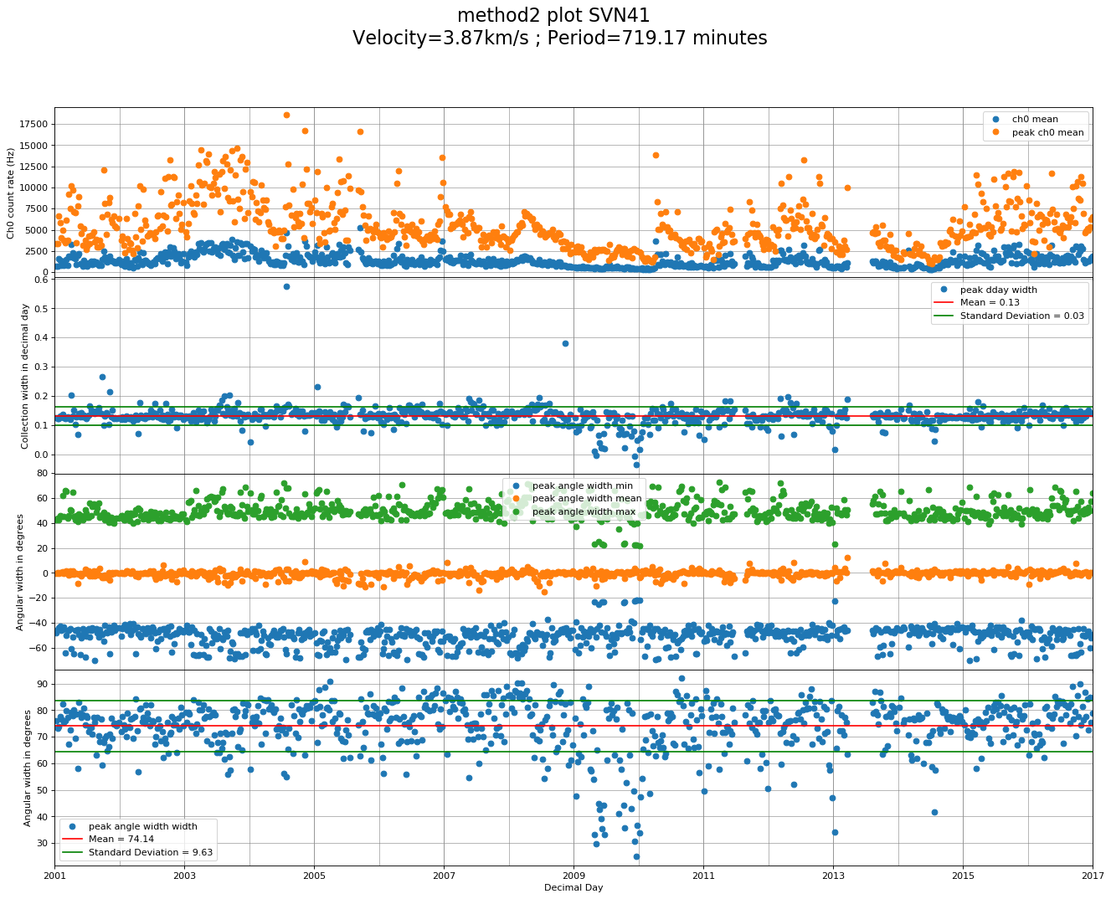

Figure 12 – Plot of averaged values from data files for full 16 years of data for ch0 electron rate (mean, max), collection width in decimal day, angular width (min, max, mean), and angular width (max-min) against decimal day for SVN 41; Width addition of calculated velocity and orbital period.

Based upon results from figure 11, ch0 was chosen to provide the electron rate components of figure 12. Between 2002 and 2004 ch0 mean and peak mean saw an increase in count rate and data spread, this behaviour also occurs between 2010 to 2013 and 2015 to 2017. Between 2007 and 2010, and again between 2014 and 2015, both the count rate and data spread are lower than surrounding time frames. The decimal day width of a peak, like one seen in figure 11 electron rate vs. date, provides a figure of (0.13±0.03) days or around (3.12±0.72) hours. In terms of angle, the spread total is between (55±15)° above the equator. At any given week, the spread is on average (74.14±9.63)°. Between 2009 and 2010, there is a noticeable dip in both angular and decimal day width of the peaks. Additional plots in [APPX 6], angular FOV is(62.06±15.33)°.

# Discussion

The existence of a well-defined peak in the ∆T distribution histogram for SVN 41 (figure 5), between +1 and +3 hours, suggests that disturbances in the outer Van Allen radiation belts can be connected to pre-seismic processes. However, comparing the confidence level obtained from SVN 41 (figure 6) to similar results from Aleksandrin, et al., the confidence obtained is lower. Furthermore, results from Aleksandrin, et al. only show a singular peak in the confidence vs. ∆L plots at 0.07 which differs greatly from the dual peaks, at 0.03 and 0.13, seen in figure 6. The exact cause of the lower confidence could be due to an incorrect capture altitude; however, the cause of the dual peaks is currently unknown.

Unfortunately, ∆T distribution histogram for other GPS satellites (SVN48, 70, 71, 72, 73) do not show a well-defined peak which suggests the opposite; that there is no connection between disturbances in the outer Van Allen belt and pre-seismic processes. Likewise, at least in the case of SVN 48, the confidence vs. ∆L plot (figure 8) reflects this which confidence that is lower than with SVN 41. Though the likelihood that both SVN 41 & 48 have two peaks at nearly the same ∆L points, 0.03 and 0.13 or 0.14 respectively, suggests that the dual peak nature is not an anomaly. A possible cause of the reduced confidence of SVN 48 might be in part explained by the number of events in the ∆T distribution histogram. As with SVN 41 (figure 5), the average for the background is approximately 30 events. If compared to SVN 48 (figure 7), it should be clear that the average for the background at greater than 60 events. Further considerations into the fact that SVN 41 had been collecting data since 2001, compared with SVN 48’s 2008 start point suggests that there is an issue with SVN 48, or the definition of what a particle burst is.

Similar issues can be seen with SVN 70-73 though rather than a reduced confidence, the confidence appears to be higher than what Aleksandrin, et al. reported, exceeding 7 $σ$ whereas Aleksandrin, et al. reported values around 6 $σ$. With SVN 70-73, rather than an increase in the number of events we see a major decrease. There are two likely causes for this; the first is that SVN70-73 only have around 1 year of data and thus few events, and secondly, the ∆L cut is so low that the number of events is most likely skewing results. The latter of which Aleksandrin, et al. pointed out.

Given the exploration into how the capture altitude would affect the confidence value was done with SVN 73 (figure 10), and considering the amount of variation between the point and lack of clear trend, while there is the suggestion of capture altitude between 550km and 700km, the certainty of this result is questionable.

Further questions are raised when considering the angular and temporal location of most of the ch2 results when observing figure 11. Opposed to other energy channels which tend to occur between -40° to +40° and within the same peak temporally, ch2 can be found between 0° and +70° or between -70° and 0° which suggests it occurs outside the outer Van Allen belt extent. The exact reason why this phenomenon only occurs at one or the other extreme makes it hard to explain. Though it is enough indication that ch2 electron rate should not be used for particle burst identification.

It can be seen with figure 12, ch0 count rate vs. decimal day, that the trends present approximately align with those that can be seen in figure 2, which shows sunspot numbers (monthly mean), though with an apparent time delay of 2 years. While this does appear to show some connection, as they do not quite line up temporally, they could be considered independent. It’s likely that alternative measures of solar activity will better match the observed trends.

The angular spread of the outer Van Allen belt was found to be (55±15)° above the equator which covers the value stated in the book ‘*Introduction to Geomagnetically Trapped Radiation’* by M. Walt (2005) at 65°. Though in a few cases, the value found with some satellites falls short by as much as 15°. The angular FOV, or the angular spread during any given week, was given at (62.06±15.33) ° where the midpoint varies by as much as 15°. What all this suggests is that either the outer Van Allen belt has an angular volume of 60° which fluctuates by approximately between the extremes of 65° or it suggests a limitation with the method of measurement.

# Conclusions

Experimental results from GPS satellites, in medium earth orbit, on the observation of high energy particle bursts from the Van Allen radiation belts can partially show a temporal and spatial correlation with earthquakes. Given the lack of definitive evidence and further findings with the exploration into the angular location of the channel 2 electron rate, I can conclude that ch2 should not be used for particle burst analysis as it falls outside of the outer Van Allen belt. Ignoring this factor, there is the implication that the capture altitude for the electromagnetic emission should be much higher than what was stated in previous works at between 550km and 700km, opposed to 300-500km. Given the difference between the orbits of satellites used and which belt they interact with this could be expected.

Furthermore, I can confirm the angular extent of the outer Van Allen belt to be around 65°.

Given the L-shell coverage that GPS satellites offer and this initial look into the appearance of what seem to be particle bursts of seismic origin. It will be necessary for continued studies into this dataset as it poses to offer not only more data to work with, but more up to date data. I foresee that further exploration with potentially lead to the development of an earthquake forecasting system.

*Acknowledgements. I would just like to thank Dr Chris Steer for providing some guidance with this project as his help was invaluable at times. I would also like to acknowledge work done by Filip M. Wach as my project was built upon code created for his study. Finally, I would like to thank my fellow students as they provided a few ideas.*

# References

|  |  |
| --- | --- |
| [1] | F. M. Wach, "A Study of Van Allen Belt Signatures of Nuclear Weapon Tests for Future CTBT Technologies," ,, Bristol, 2017. |
| [2] | The CXD team at Los Alamos National Laboratory, "Contents of GPS Energetic Charged Particle Data Product Files," Los Alamos National Laboratory , Los Alamos, 2016. |
| [3] | S. Y. Aleksandrin, A. M. Galper, L. A. Grishantzeva, S. V. Koldashov, L. V. Maslennikov, A. M. Murashov, P. Picozza, V. Sgrigna and S. A. Voronov, "High-energy charged particle bursts in the near-Earth space as earthquake precursors," *Annales Geophysicae,* vol. 21, pp. 597-602, 2003. |
| [4] | M. Walt, "1 The Earth's radiation belts," in *Introduction to Geomagnetically Trapped Radiation*, New York, Cambridge University Press, 2005 [Originally published 1994], pp. 1-9. |
| [5] | NASA, "Magnetospheres," NASA, n.d.. [Online]. Available: science.nasa.gov/heliophysics/focus-areas/magnetosphere-ionosphere. [Accessed 26 3 2018]. |
| [6] | M. B. McElroy, "Ionosphere and magnetosphere," Encyclopaedia Britannica, Inc., 8 8 2012. [Online]. Available: www.britannica.com/science/ionosphere-and-magnetosphere/Magnetosphere. [Accessed 26 3 2018]. |
| [7] | K. C. Fox, "NASA's Van Allen Probes Spot an Impenetrable Barrier in Space," NASA, 26 11 2014. [Online]. Available: www.nasa.gov/content/goddard/van-allen-probes-spot-impenetrable-barrier-in-space. [Accessed 26 3 2018]. |
| [8] | W. N. Spjeldvik and P. L. Rothwell, "The Earth's Radiation Belts," *Environmental Research Papers,* vol. 854, pp. 1-13, 1983. |
| [9] | Parsec vzw, "Solar Cycle progression," SpaceWeatherLive.com, n.d.. [Online]. Available: www.spaceweatherlive.com/en/solar-activity/solar-cycle. [Accessed 02 04 2018]. |
| [10] | NASA; IMAGE Education Center, "The Van Allen Belts.," NASA, n.d.. [Online]. Available: image.gsfc.nasa.gov/poetry/tour/AAvan.html. [Accessed 27 3 2018]. |
| [11] | N. Sivadas, "HIGH ENERGY PARTICLE BURSTS AS SEISMIC PRECURSORS," Bangalore, 2010. |
| [12] | N. P. Sergeenko and A. L. Kharitonov, "Short-temporal Magnetosphere-ionosphere Predictors of Catastrophic Earthquakes," in *PIERS*, Stockholm, 2013. |
| [13] | J. McDowell, "Satellite Catalog," n.d.. [Online]. Available: planet4589.org/space/log/satcat.txt. [Accessed 29 03 2018]. |
| [14] | J. J. Lee, "How Do Earthquake Early Warning Systems Work?," National Geographic, 28 9 2013. [Online]. Available: news.nationalgeographic.com/news/2013/09/130927-earthquake-early-warning-system-earth-science/. [Accessed 31 03 2018]. |
| [15] | A. M. Galper, S. V. Koldashov and S. A. Voronov, "HIGH ENERGY PARTICLE FLUX VARIATIONS AS EARTHQUAKE PREDICTORS," *Adv. Space Res.,* vol. 15, no. 11, pp. 131-134, 1995. |
| [16] | USGS, "Search Earthquake Catalog," n.d.. [Online]. Available: earthquake.usgs.gov/earthquakes/search/. [Accessed 20 12 2017]. |

# Appendices

[APPX 1]

A single Earth Radii, $R_{E}$ is approximately equal to 6379km.

[APPX 2]



[APPX 3] ∆T distribution histograms for SVN 41

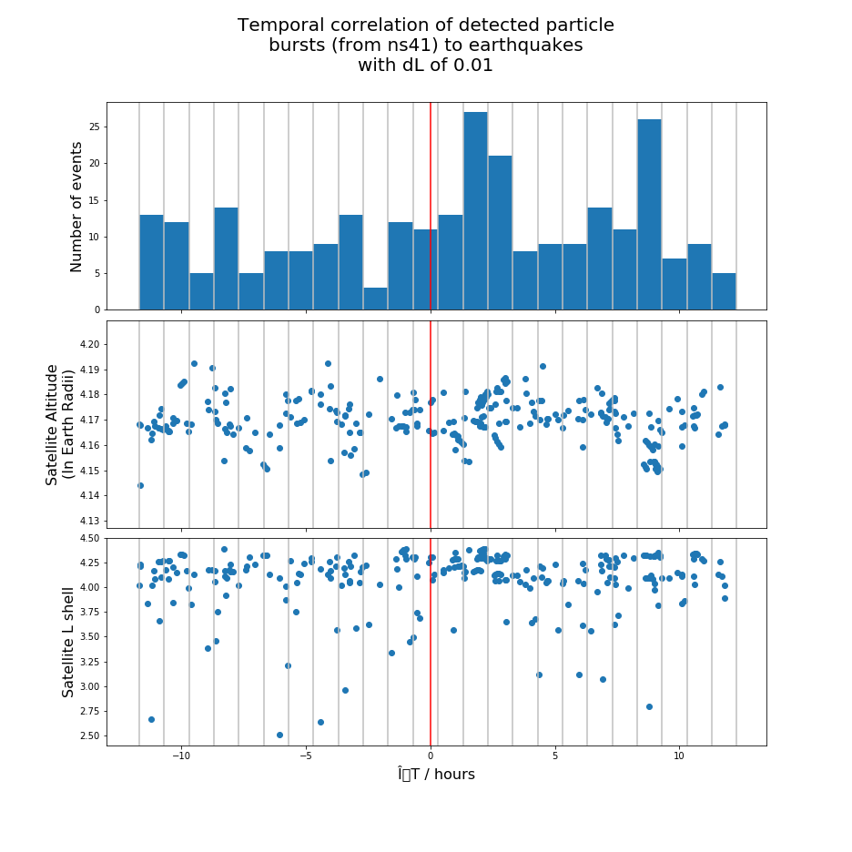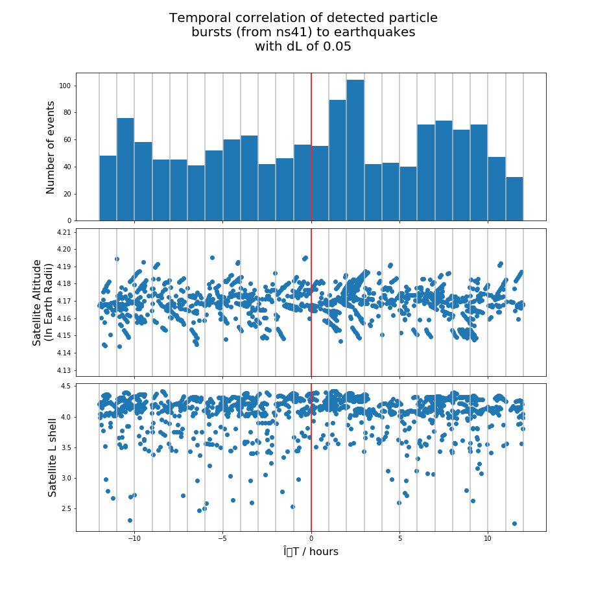

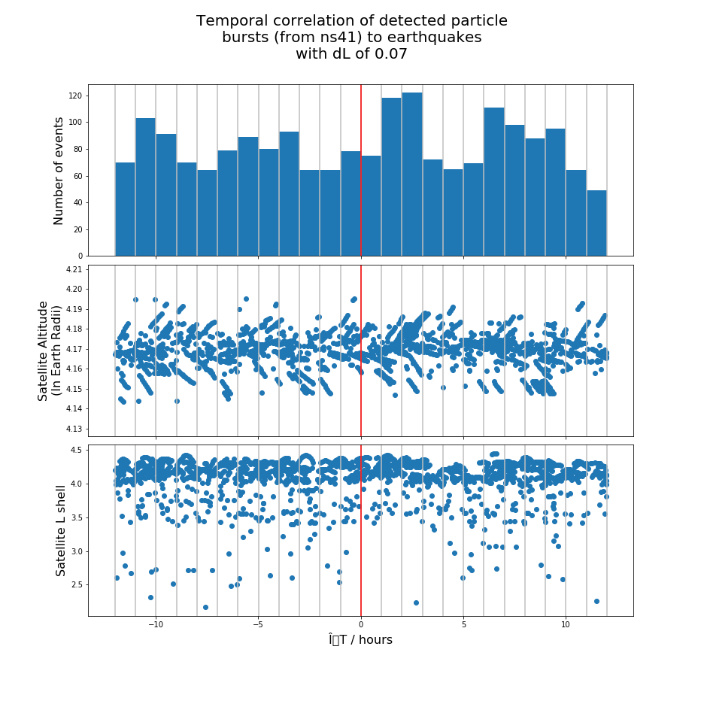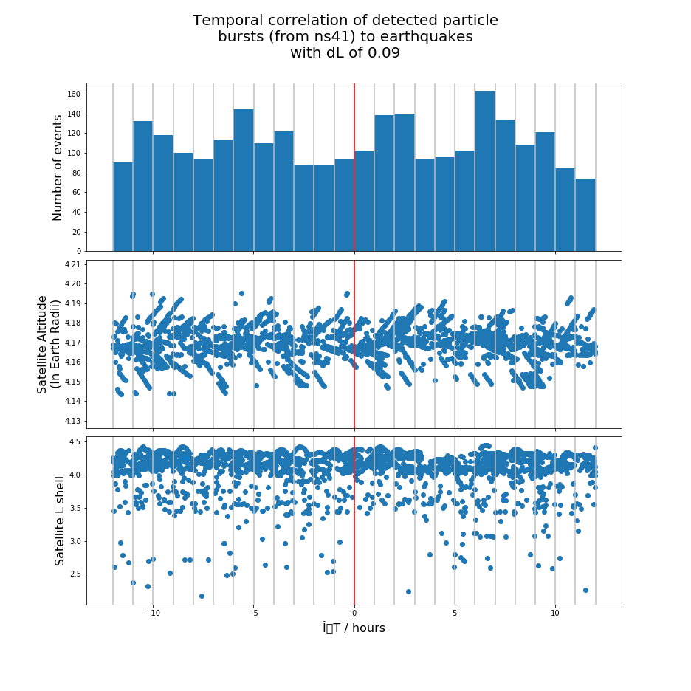

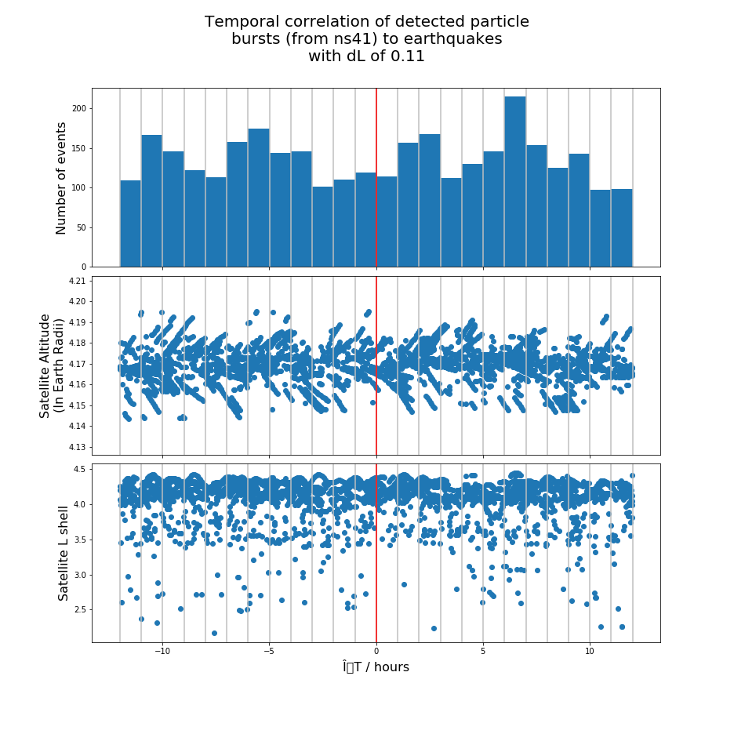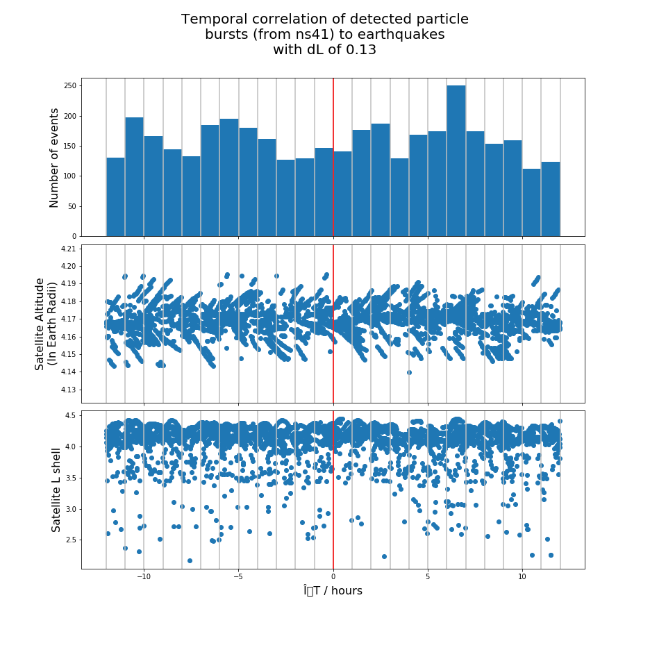

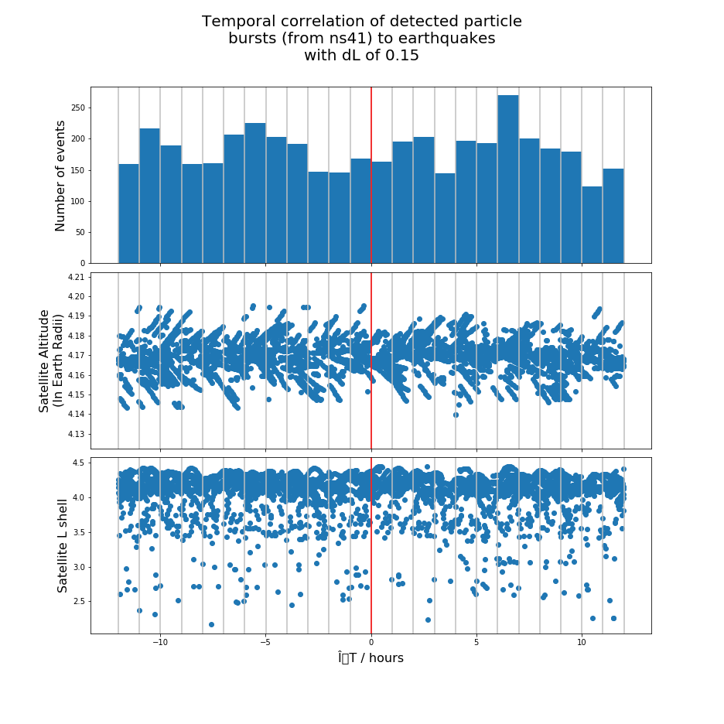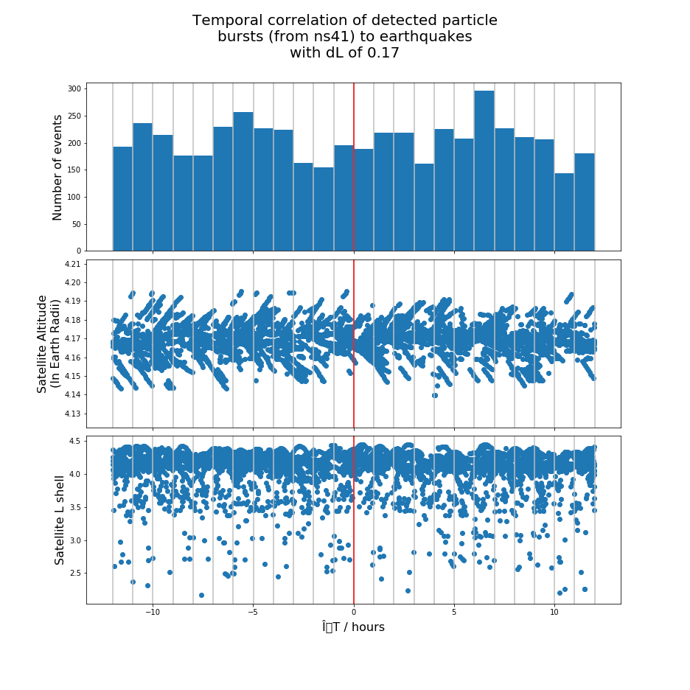

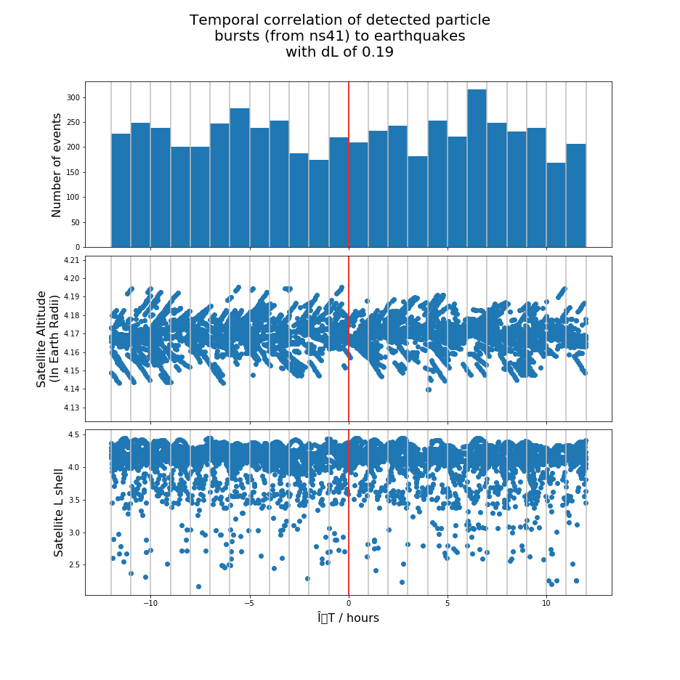

[APPX 4] ∆T distribution histograms for SVN 48

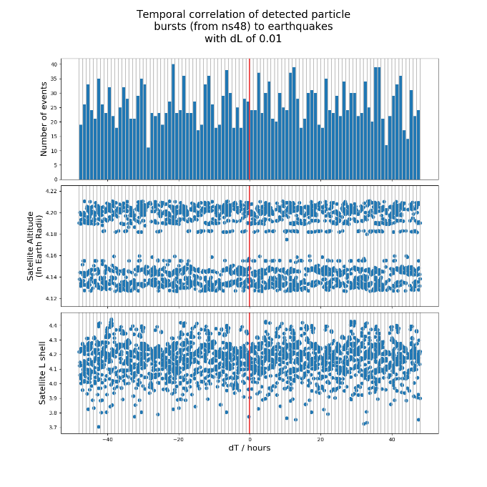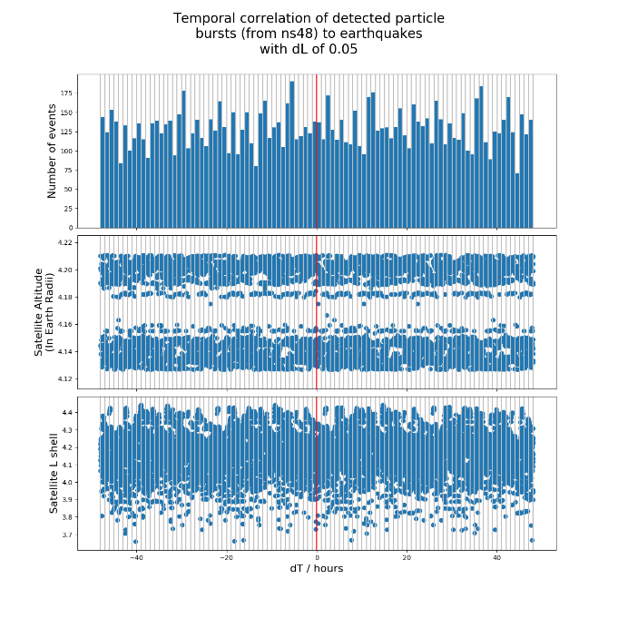

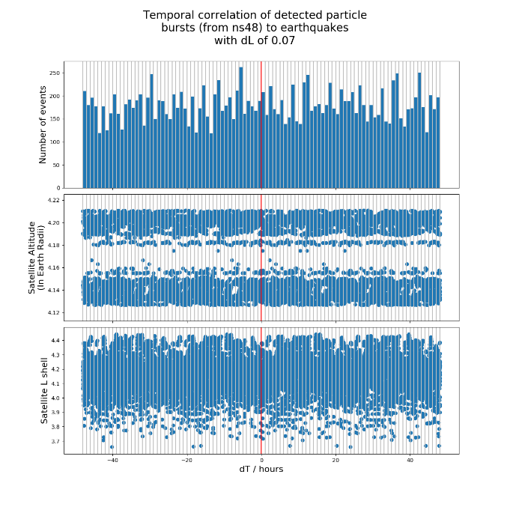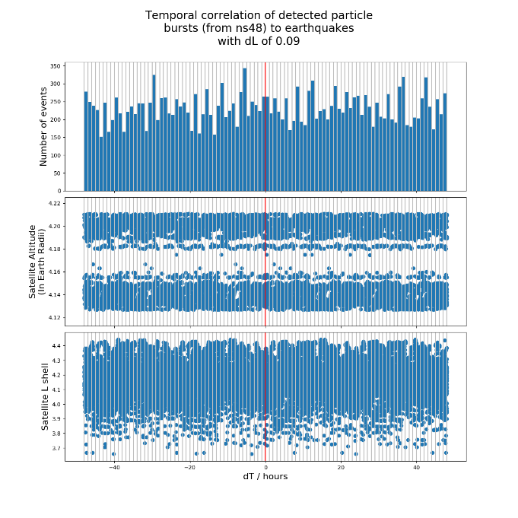

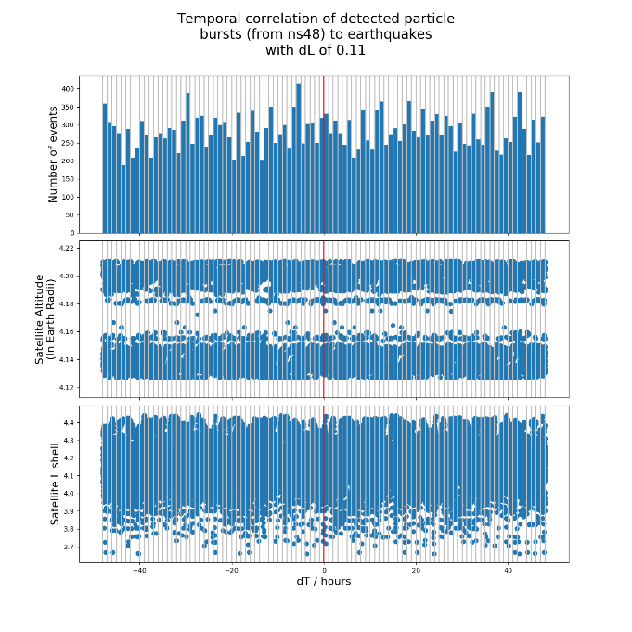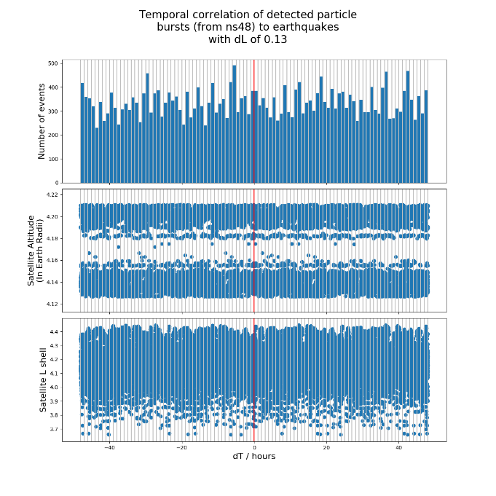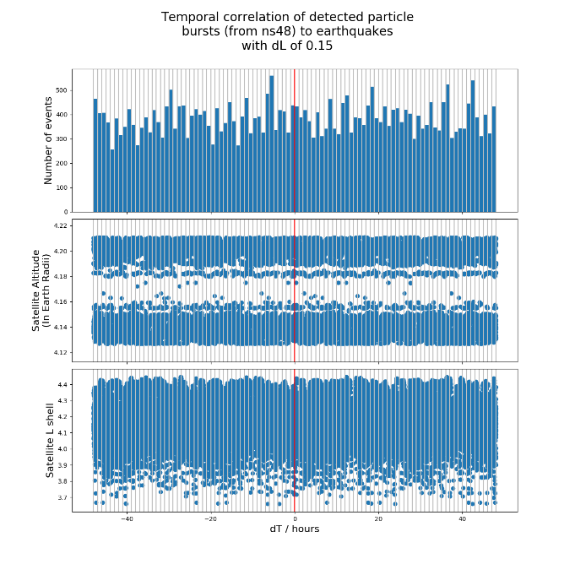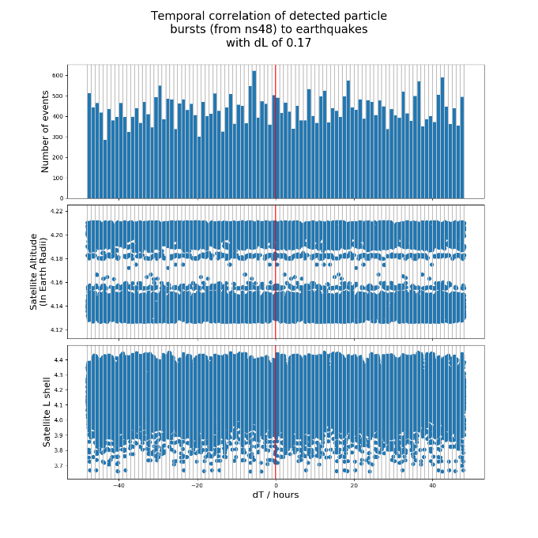

[APPX 5]

SVN 41 2002-07-21 to 2002-07-27

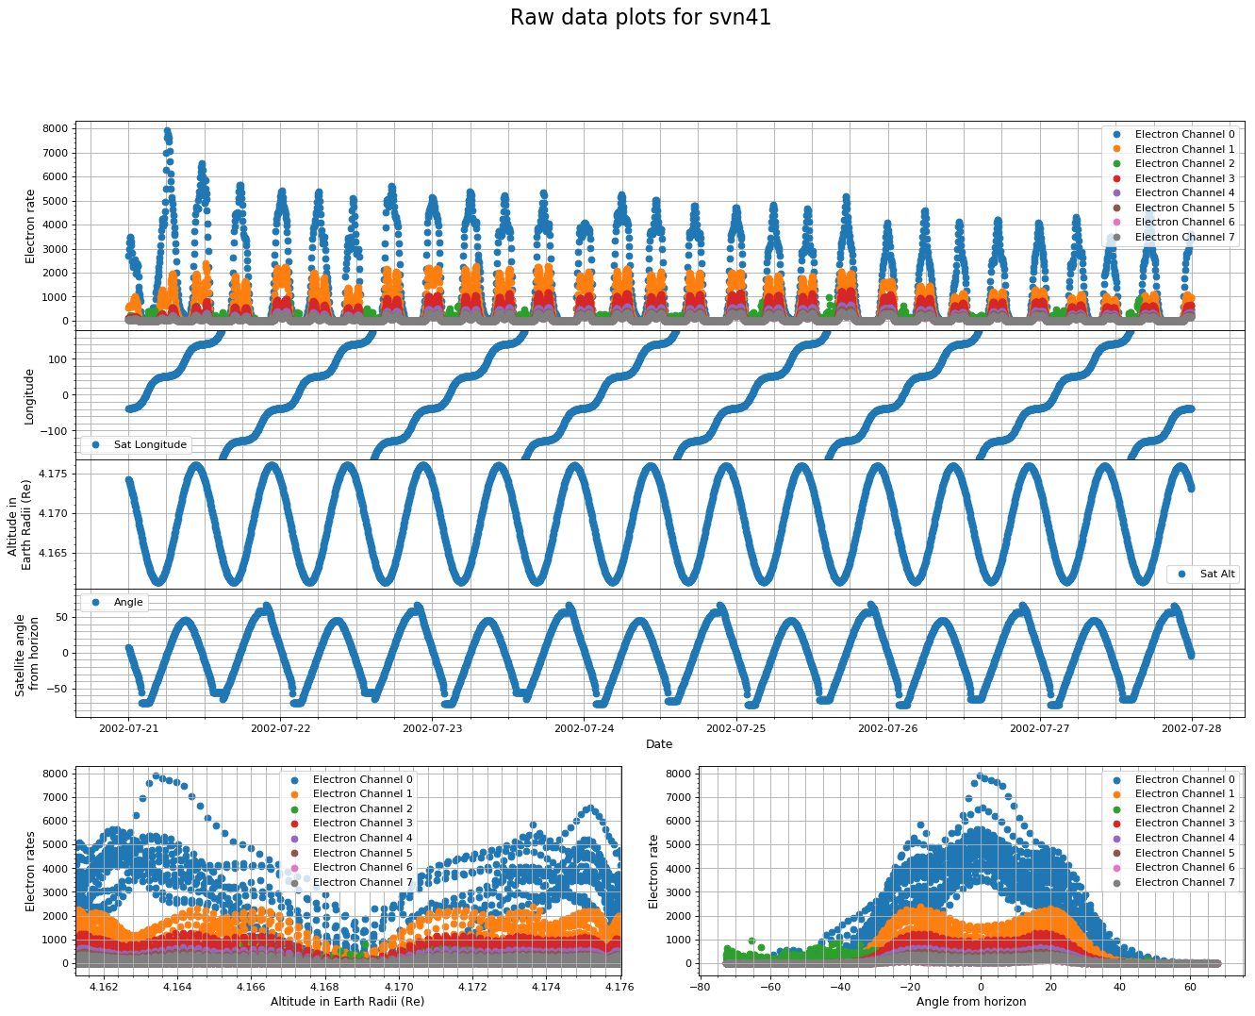

SVN 41 2003-10-19 to 2003-10-25

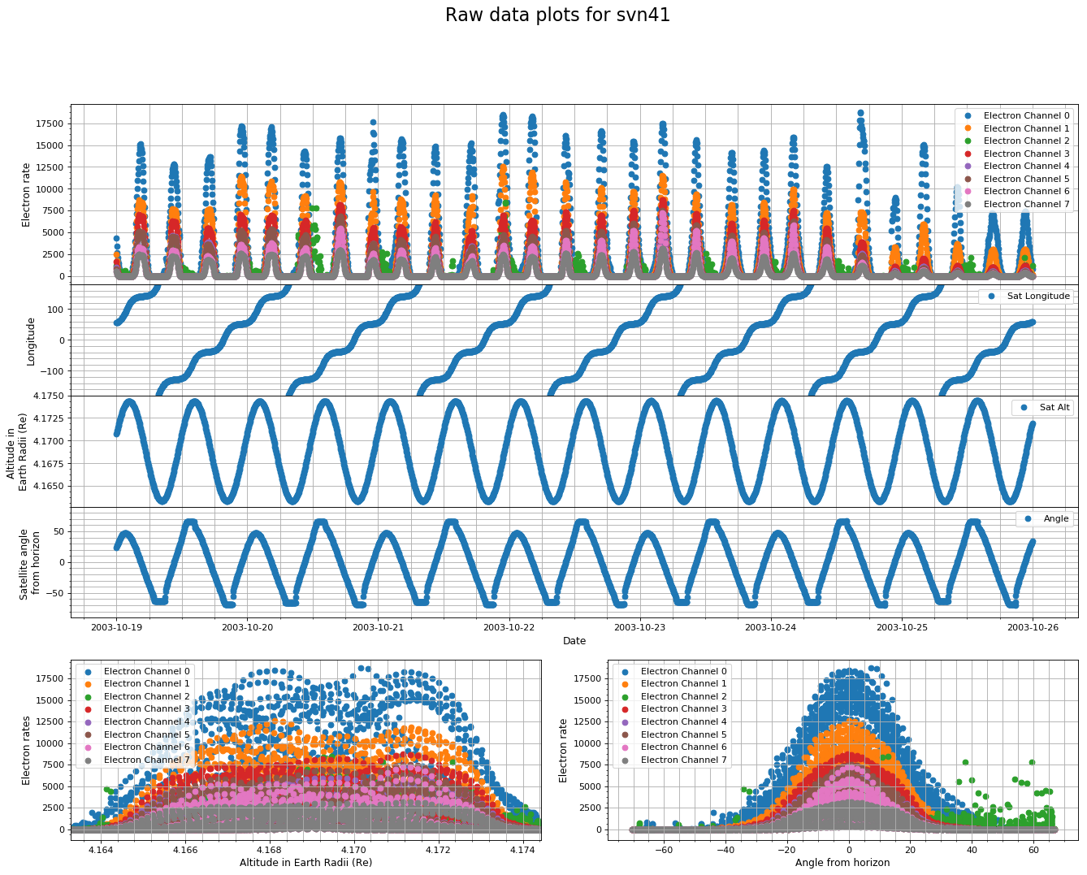

SVN 41 2006-04-09 to 2006-04-15

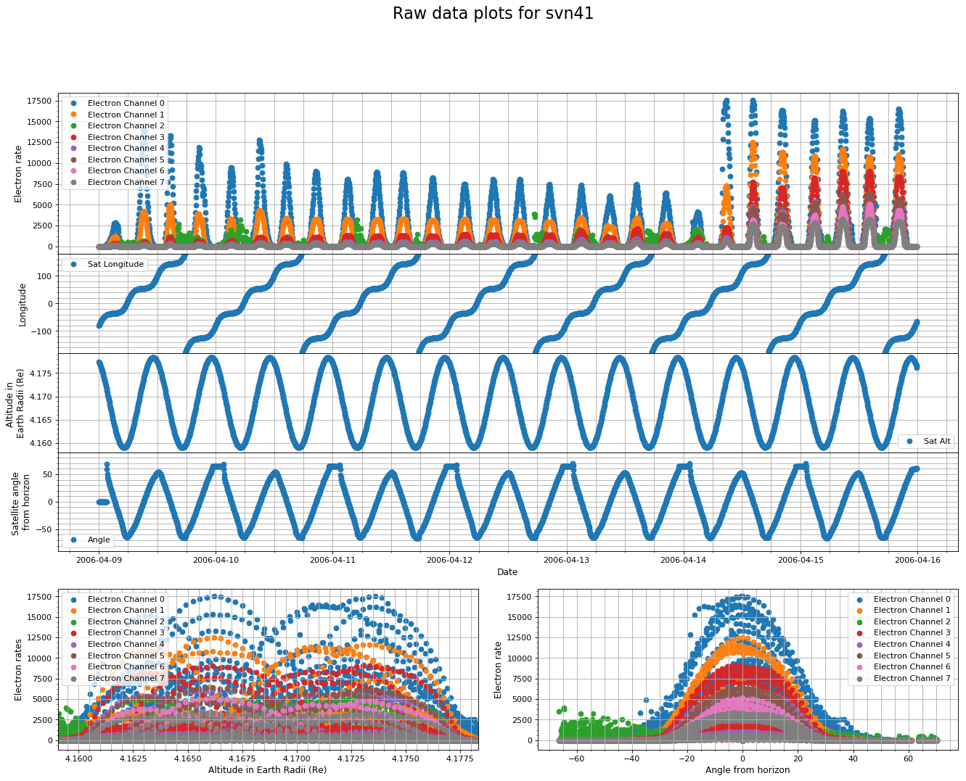

SVN 41 2010-05-02 to 2010-05-08

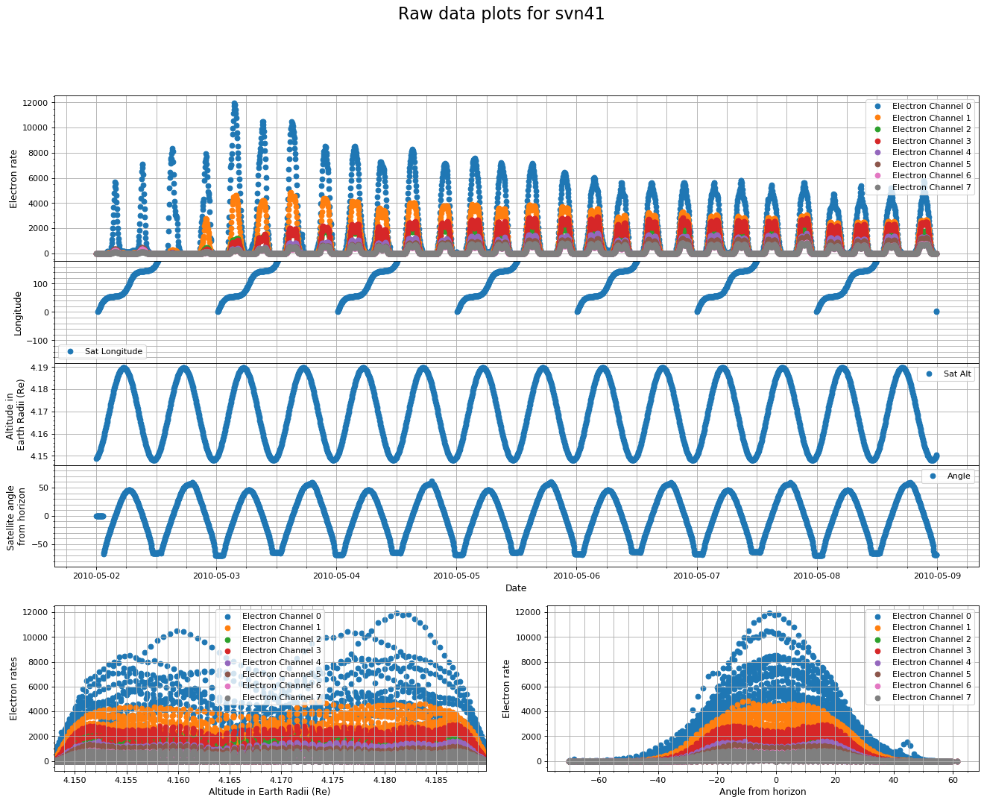

[APPX 6]

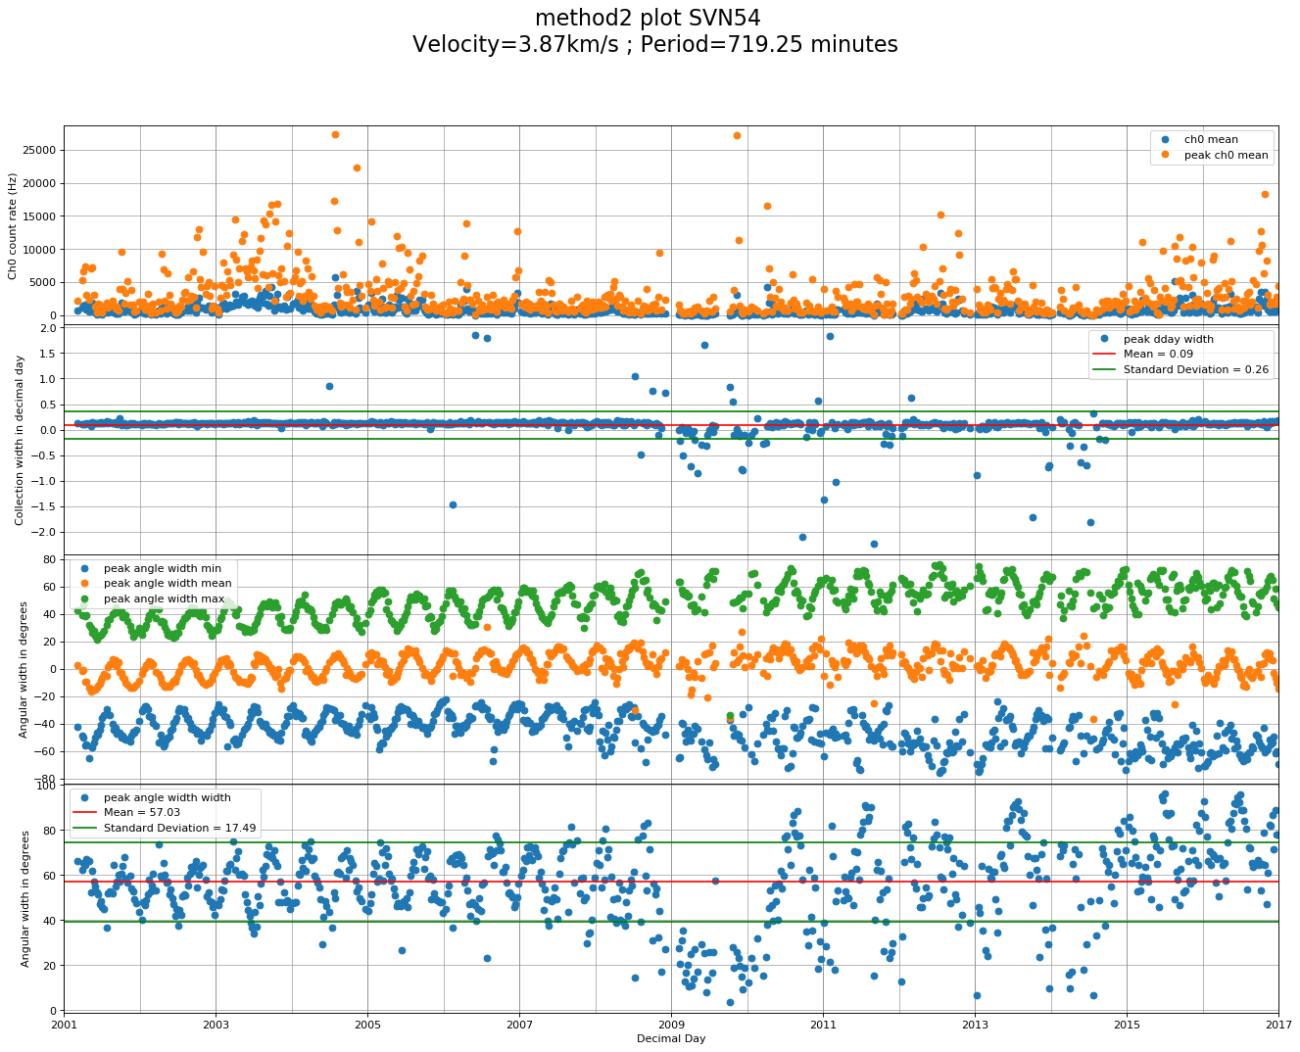

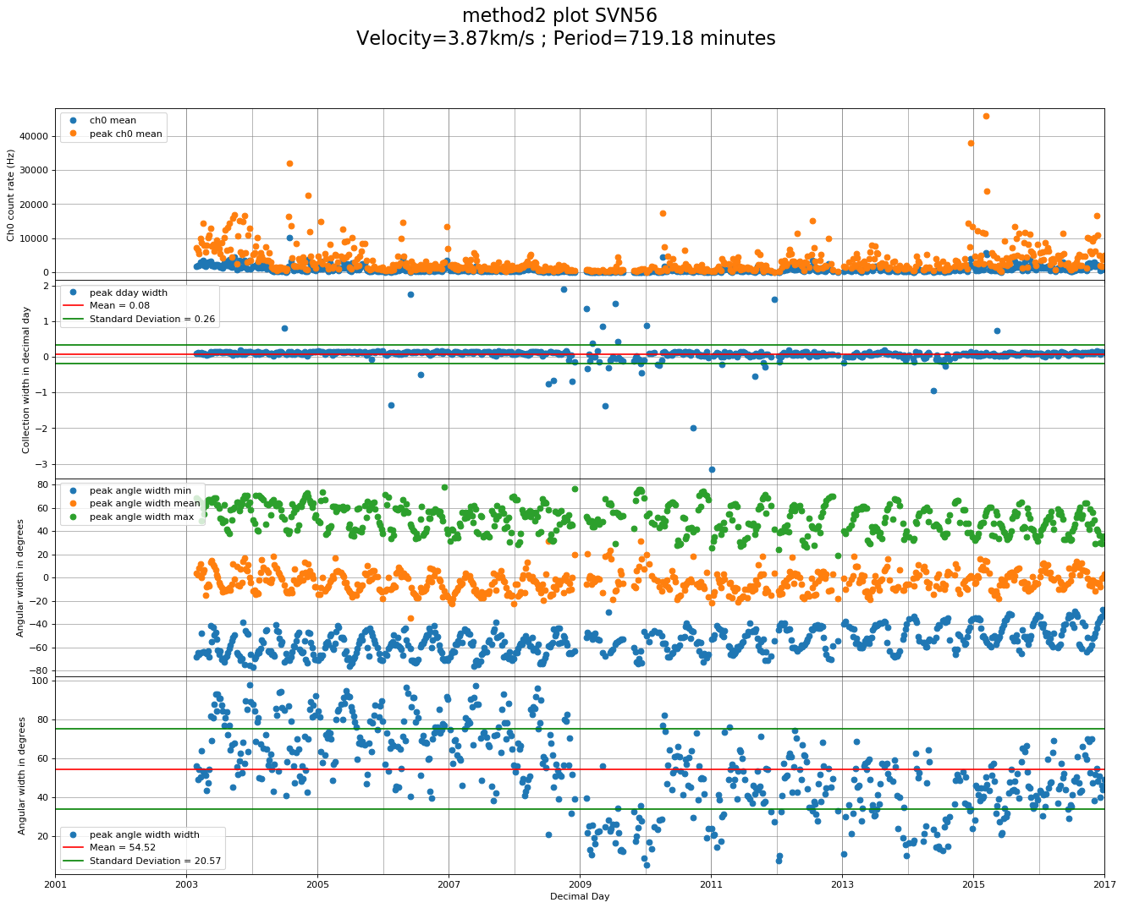

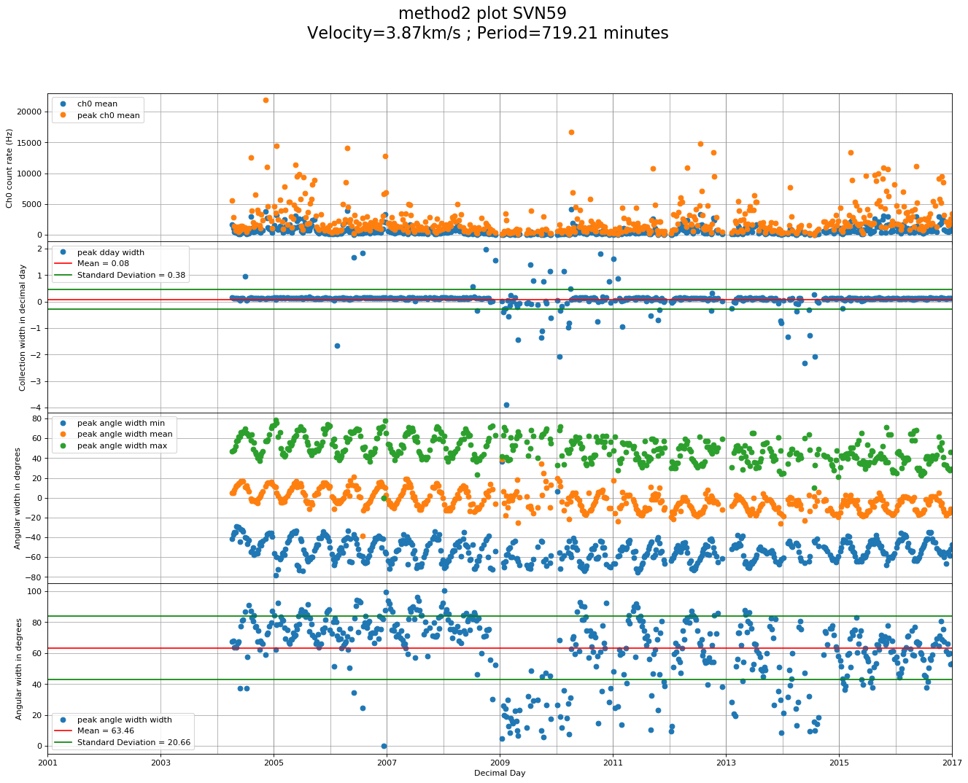

[APPX 7]

Full Python 2.7 source code can be found here: github.com/jackjt8/EQPB_2017

**-END-**